

Portable Test Pump Manual Instruction
HHS-340

www.barton-tools.com

Do not operate without reading the operation manual and installing leakage protection device

1. Suitable range
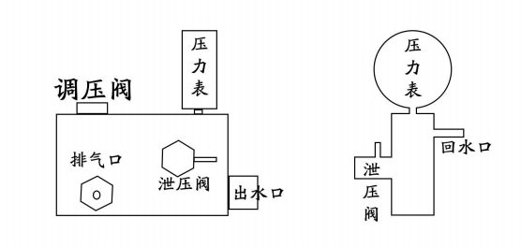
Electric pressure test pump is suitable for all kinds of pipeline pressure vessels, pressure resistant parts for pressure test, suitable for chemical industry, construction, plumbing and other industries. The machine has simple structure, easy to use, especially the large flow to improve work efficiency.

www.barton-tools.com
2. Technical parameter
1. Name：HHS-340
2. Power：1.5KW
3. Voltage：220V
4. Pressure Range：0-6MPA
Connector Ways
5. Flow：480L/H
6. G.W.：15KG

3. Operational approach

1.Connect the power, fill the tank with water。
2.Connect the high pressure pipes as drawings, tighten and seal the interface of the tested pipe.
3.Open the electric switch, loosen the pressure relief screw, tighten the pressure relief screw when the water flows out of the pressure relief valve.
4.Loosen the hexagon nut of the handle, turn the pressure handle down
slowly, then check the numerical of the pressure gauge till to the required
pressure, tighten the hexagon nut, keep the pressure no change.
5.Check whether the numerical of pressure gauge decreases, if yes, it indicate that there is leakage appearance.

www.barton-tools.com
After finish, dispatch the kind pipes, then start the electric machine idling 30s, eliminate internal residual water stains.

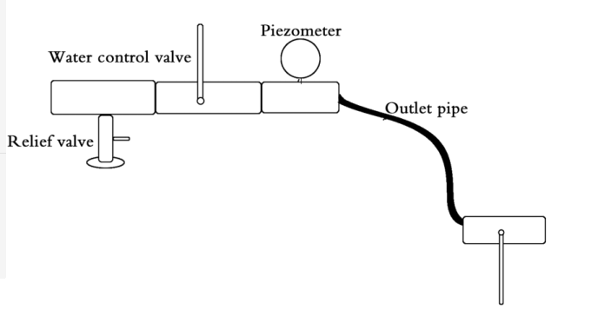

www.barton-tools.com
4. Attention
1.Before using，add the oil on the pump, forbidden testing the pump with adding oil.
2.The power should be connected on the protective device of electric leakage.
3.Must keep the water clean, in order to keep the pump body absorb the water.

5. Maintenance
1.Bad self-absorption or long time not absorb water
Check whether tighten the water inlet tap, neglected the seal gasket of water inlet tap, tighten the quick coupler of inlet pipe,the water inlet pipe broken, the machine assemble is correct.
2.When the motor is running, the water outlet of the nozzle is irregular and the phenomenon of repeated startup and shutdown occurs.
The nozzle is blocked by debris and the nozzle is cleaned with a through-mouth to discharge the debris; High-pressure water leakage machine does not protect pressure, check whether there is debris blocking pressure valve, clean up.
3.Oil leakage, water leakage, burning
Check the pump body, the seal on the pump seat is not damaged, the oil seal at the connection between the cylinder and the pump seat is not broken or deformed; Check the wear length of carbon brush; Check whether the surface of the motor commutator is black, and whether there is virtual welding, etc.

www.barton-tools.com

